ROYAL OAK INTERNATIONAL SCHOOL
SR. SEC. CBSE AFFILIATED
HOLIDAY HOME WORK (SESSION 2019-20)
Class - 1V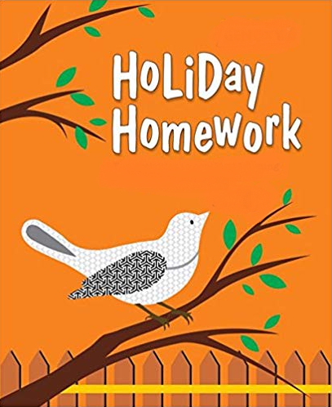

Please note the following:
- HHW of 5 marks will be added as a subject enrichment activity marks in Term I, hence submission of work post summer vacation is compulsory for all the students.
- Schedule for the Submission of HHW for all classes is as follows:
English : 3/07/2019
Hindi : 4/07/2019
Math : 5/07/2019
Science : 8/07/2019
Social Studies : 9/07/2019
- Submission dates for Computer, G.K., Art & Craft will be in the 2nd week of July.

Wishing you all a very fruitful and enjoyable vacations. HAPPY HOLIDAY!

FOR THE PARENTS

Summer Vacations are here. A few vital suggestions are listed below to make the vacations more exciting and fruitful than ever before:
- Keep at least half an hour a day for sharing experiences with your child.
- Encourage your child to speak in English. Fix one hour in a day when you communicate with your child only in English.
- Tell your child different stories regularly and encourage him/her to describe what he/she would do in a similar situation. Here are few suggested titles which you can read with your child.
a. Lacey-the little mermaid fairy d. Giraffe can’t dance
b. I like myself (Story book) e. Dolphins at the day break
c. Panchatantra stories
- Let your child colour, draw, paint, Play, Dance etc.
- Restrict his/her television watching, confining it to interesting children’s program, cartoon films, discovery channel etc.
- To improve the formation of letter, make your child write a page every day.
- Develop self help skills: Let your child dress and feed on his/her own.
- Make him/her understand the importance of cleaning his/her room and putting away toys and belongings after use.
- Take your child out for picnics and to other places of his/her interest. Ask him/her to make a note of all the places he/she visits and things he/she sees so that he/she is able to discuss his/her experience in class after vacations.
Have a nice time!
PRINCIPAL

ENGLISH:
Tongue twisters are great fun. Try learning these tongue twisters and practicing saying these quickly as possible. We will be organizing an intra-class tongue twister competition in the class after the summer vacation. So. Learn these tongue twisters and come prepared.
- She sells sea shells by the seashore.
- Eve eating eagerly Easter eggs.
- I like New York, unique New York, I like unique New York.
2. Make a beautiful bookmark and write a quotation for your mother and father and laminate it.
3. Make a chart on “Different types of Noun” with examples and pictures.
4. “WORDS I MUST KNOW” Make a vocabulary scrapbook with 50 new words and learn them with their meanings.
5. Converse in English with your family members and listen to English news daily.

HINDI:
- ikB 1 ] 2] 3] ;kn djks A
- ^ ty dk mfpr iz;ksx dSls fd;k tk ldrk gS * A- 3 “khV ij dksykt ds ek/;e ls n”kkZb,A
- vki vius ifjokj ds dk;ksZ esa fdl izdkj enn djrs gSA A- 4 “khV ij fp= lfgr fyf[k,A
- बाघksa ds laj{k.k ds ckjs esa fp= lfgr ik¡p ls lkr iafDr;k¡ A- 4 “khV ij fyf[k,A
- fofHkUu izdkj ds psgjs cukdj A- 4 “khV ij fpidk,A
MATH:
1. Prepare a small notebook and do the following work in it.
a) Ch- 1 (Revision)
b) Ch-2 (Roman Numerals)
2. Find out the date of birth of your family members. Using matchsticks write the date of birth in roman numerals on A-4 size sheet.
3. Revise all the work done in a class for P.A-I
4. Learn and write tables from 2-20.

SCIENCE:
- Leaf animal art- Collect some leaves of different shapes and sizes. Make any two animals using dried leaves on A-3 sheet.
- Draw the life cycle of the following animals on A-4 sheet according to your ROLL No.(refer to your course book)
- ROLL No-1-10- Life cycle of a frog
- ROLL No – 11 to 20-Life cycle of a hen
- ROLL No-21 to 30 –Life cycle of a butterfly
- Learn L-3, 6, 7and 9

SOCIAL SCIENCE:
- Write any 10 countries with their capitals and currencies on A4 Sheet along with the images of
their flags.
2. Make a model of dam using waste materials.
3. Make flash cards and write the information about these Reformers, Mathematicians,
Astronomers and Physicians according to your Roll no.
i. Kabir_____Roll no.(1-5)
ii. Aryabhatta_____________ Roll no.(6-11)
iii.Varahmihira____________Roll no.(12-17)
iv.Charak and Sushrut____________Roll no.(18-24)
v.Ashoka the great______________Roll no.(25-29)
vi.Akbar the great____________Roll no. (30-34)
- Revise all the chapters done in class.

COMPUTER:
- Revise P.A.-I Syllabus
- Do page no 69 in book(Activity 3)
- Write shortcut key commands in notebook .(Refer pg-61& 62)
- Paste/Draw Pictures related to topic mentioned below and paste them on A3 sheet.
- Roll No. 1 – 8 Input devices
- Roll No. 9 – 16 Output devices
- Roll No. 16-24 Memory devices
- Roll No. 25 onwards Pen block commands(Refer Pg - 121)

G.K.:
1. (a) Paste the pictures of any six Industrial Towns of the World and write why they are famous for. (on A3 size sheet) (Roll No. 1 to 15)
(b)Sports are very important for our health. Sports symbols are commonly used in sports. Draw or paste pictures of any ten Sports Symbols and write the names of the related sports. ( on A3 size sheet) ( Roll No. 16 onwards)
2. Revise P. A. I Syllabus.

ART & CRAFT:
1. Decorative paper purse
2. Paper tree (Ref. page no 37 in Art book)

